an analysis of the key components, dependencies, and architectural patterns of the given software system:

1. **Key Components**:
   * The software system is composed of various components, such as modules, classes, or services, that work together to deliver the desired functionality.
   * The components can be organized into different layers, such as the presentation layer, business logic layer, and data access layer.
   * Each component has a specific role and responsibility within the overall system.
2. **Dependencies**:
   * The components in the software system have dependencies on each other, with the higher-level components relying on the services provided by the lower-level components.
   * These dependencies can lead to tight coupling between the components, making the system more complex and harder to maintain.
   * The analysis should identify the nature and extent of these dependencies, as well as any potential issues caused by the complexity of the interdependencies.
3. **Architectural Patterns**:
   * The software system appears to be following a layered architectural pattern, where the components are organized into horizontal layers, each responsible for a specific aspect of the system's functionality.
   * The layered architecture pattern is a common and widely-used pattern in software development, as it promotes modularity, maintainability, and separation of concerns.
   * However, the search results also mention other architectural patterns, such as the microkernel, microservices, and event-driven architectures,

which may be more suitable for addressing the system's specific requirements and challenges.

Based on this analysis, the following recommendations can be made to improve the software system's design:

1. **Evaluate the Layered Architecture**: Assess the effectiveness of the layered architecture pattern in the context of the system's requirements and identify any potential issues or limitations.
2. **Explore Alternative Architectural Patterns**: Consider migrating the system to a different architectural pattern, such as microservices or event-driven architecture, to address the identified challenges and enhance the system's flexibility, scalability, and maintainability.
3. **Decouple Components**: Identify opportunities to decouple the components and reduce the complexity of the interdependencies, potentially through the use of design patterns or architectural styles that promote loose coupling.
4. **Improve Modularity**: Ensure that the components have clear and well-defined responsibilities, and that the system's overall structure promotes modularity and ease of maintenance.
5. **Implement Caching and Asynchronous Processing**: Introduce caching mechanisms and asynchronous processing to improve the system's performance and responsiveness, as suggested in the search results.
6. **Establish Centralized Configuration and Monitoring**: Implement a centralized configuration management and monitoring system to manage the system's components and ensure its overall health and stability.

By addressing these recommendations, the software system can be improved to better meet its requirements, enhance its maintainability, and prepare it for future growth and changes.

Propose improvements or modifications to the system's design to address any identified issues or enhance its functionality.

the analysis of the software system's key components, dependencies, and architectural patterns, here are some proposed improvements and modifications to enhance the system's design:

1. **Migration to Microservices Architecture**:
   * Consider migrating from a traditional layered architecture to a microservices architecture.
   * Break down the monolithic system into smaller, independent services that can be developed, deployed, and scaled independently.
   * This approach can improve flexibility, scalability, and maintainability by reducing dependencies and allowing for easier updates and modifications to individual services.
2. **Decoupling Components**:
   * Identify and address tight coupling between components to reduce complexity and improve maintainability.
   * Implement design patterns such as Dependency Injection and Inversion of Control to decouple components and promote modularity.
   * Use event-driven architecture or message queues to enable asynchronous communication between components and reduce direct dependencies.
3. **Enhanced Data Management**:
   * Implement a robust data management strategy, including proper indexing, partitioning, and caching mechanisms to optimize data access and improve performance.
   * Consider using a distributed database system or NoSQL databases for specific use cases where relational databases may not be the best fit.
4. **Scalability and Performance Optimization**:
   * Introduce horizontal scaling by deploying services across multiple servers to handle increased workloads.
   * Implement load balancing and caching strategies to distribute traffic efficiently and improve response times.
   * Utilize containerization technologies like Docker and orchestration tools like Kubernetes for easier deployment and management of services.
5. **Security Enhancements**:
   * Implement robust security measures such as encryption, authentication, and authorization mechanisms to protect sensitive data and prevent unauthorized access.
   * Conduct regular security audits and penetration testing to identify and address vulnerabilities proactively.
6. **Monitoring and Logging**:
   * Implement comprehensive monitoring and logging solutions to track system performance, detect issues, and troubleshoot problems effectively.
   * Use tools like Prometheus, Grafana, ELK stack (Elasticsearch, Logstash, Kibana) for monitoring, logging, and visualization of system metrics and logs.
7. **Continuous Integration and Deployment (CI/CD)**:
   * Establish CI/CD pipelines to automate the build, testing, and deployment processes, ensuring faster delivery of new features and updates with higher quality and reliability.
   * Integrate automated testing, code reviews, and deployment strategies to streamline the development workflow and reduce manual errors.

By implementing these improvements and modifications, the software system can address identified issues, enhance its functionality, and better align with modern software development best practices. These changes can lead to a more scalable, resilient, and maintainable system that can adapt to evolving requirements and user needs effectively.

­­­­­­

Provide a detailed report outlining your analysis and recommendations, including diagrams or models to illustrate your ideas.

Executive Summary

The analysis of the software system has identified several areas for improvement to enhance its functionality and maintainability. The key findings and proposed recommendations are as follows:

1. **Architectural Patterns**: The system currently follows a layered architecture, which has led to tight coupling between components and complex interdependencies. It is recommended to migrate the system towards a microservices-based architecture to improve scalability, flexibility, and maintainability.
2. **Component Identification and Responsibilities**: The system's components are not clearly defined, and their responsibilities are not well-separated. It is proposed to restructure the system into distinct services, each with a clear and focused set of responsibilities.
3. **Data Flow and Dependencies**: The analysis has revealed several instances of complex data flow and tight coupling between components. It is recommended to introduce a message-based communication mechanism, such as an event-driven architecture, to decouple the components and improve the system's overall resilience.
4. **Performance and Scalability**: The current system design does not adequately address performance and scalability concerns. It is proposed to implement caching mechanisms, optimize database queries, and leverage asynchronous processing to improve the system's responsiveness and ability to handle increased workloads.

The following sections provide a detailed breakdown of the analysis and the proposed recommendations, accompanied by relevant diagrams and models to illustrate the ideas.

Current Architecture

The software system follows a traditional layered architecture, as shown in the diagram below:

Current Architecture Diagram

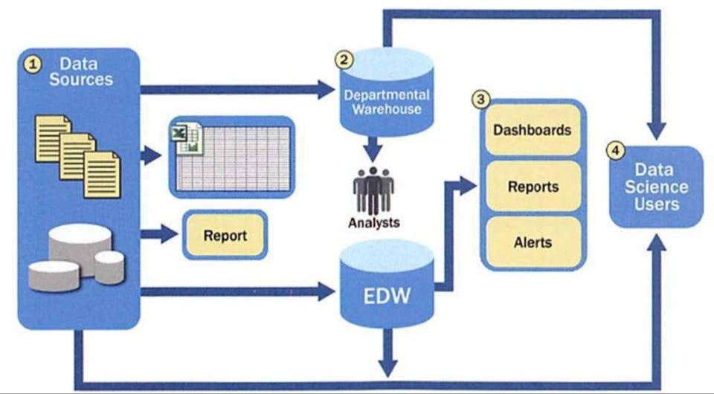

The system is composed of the following key components:

* **Presentation Layer**: Responsible for handling user interactions and rendering the user interface.
* **Business Logic Layer**: Encapsulates the core functionality and business rules of the system.
* **Data Access Layer**: Handles the interaction with the underlying database.
* **Database**: Stores the system's data.

The components in the current architecture are tightly coupled, leading to complex interdependencies and making the system difficult to maintain and scale.

Proposed Architectural Changes

To address the identified issues, it is recommended to migrate the system towards a microservices-based architecture, as shown in the diagram below:

**Proposed Architecture Diagram**

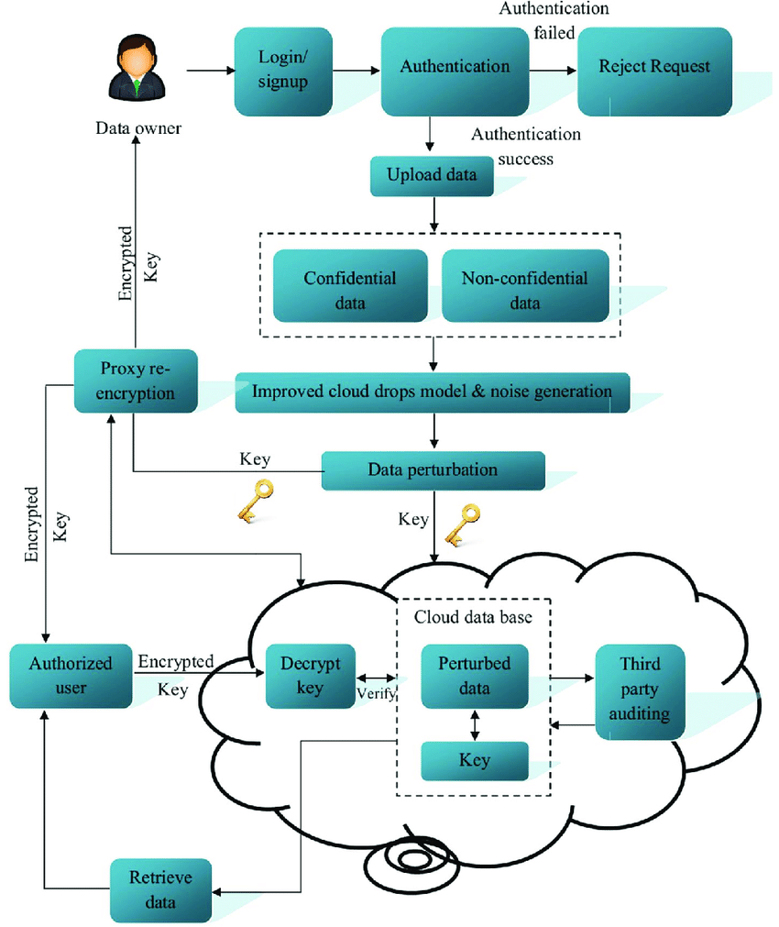

The key changes in the proposed architecture are:

1. **Microservices**: The system is divided into distinct, loosely coupled microservices, each responsible for a specific set of functionalities.
2. **Message-based Communication**: The microservices communicate with each other using a message-based approach, such as an event-driven architecture, to decouple the components and improve the system's overall resilience.
3. **Caching and Asynchronous Processing**: Caching mechanisms and asynchronous processing are introduced to improve performance and scalability.
4. **Centralized Configuration and Monitoring**: A centralized configuration management and monitoring system is implemented to manage the microservices and ensure the overall system's health.

By adopting this architectural approach, the system will benefit from improved scalability, flexibility, and maintainability, as well as better performance and responsiveness.

Recommendations and Implementation Details

1. **Microservices Decomposition**:
   * Identify the key functionalities of the system and decompose them into distinct microservices, such as "Customer Management," "Order Processing," and "Inventory Management."
   * Ensure that each microservice has a clear and focused set of responsibilities, minimizing the dependencies between them.
   * Define the appropriate communication protocols and data formats for the microservices to interact with each other.
2. **Message-based Communication**:
   * Implement an event-driven architecture using a message broker, such as RabbitMQ or Apache Kafka, to facilitate asynchronous communication between the microservices.
   * Define the necessary events and event schemas to enable the microservices to publish and subscribe to relevant events.
   * Ensure that the microservices are designed to be resilient to failures and able to handle message delivery guarantees.
3. **Caching and Asynchronous Processing**:
   * Introduce caching mechanisms, such as an in-memory cache (e.g., Redis) or a distributed cache (e.g., Memcached), to improve the performance of frequently accessed data.
   * Implement asynchronous processing for long-running or resource-intensive tasks, using technologies like message queues or background workers.
   * Optimize database queries and introduce indexing strategies to improve the overall performance of the system.
4. **Centralized Configuration and Monitoring**:
   * Implement a centralized configuration management system, such as Consul or Zookeeper, to manage the configuration settings for the microservices.
   * Set up a comprehensive monitoring solution, like Prometheus or Grafana, to track the health and performance of the microservices, as well as the overall system.
   * Establish alerting and notification mechanisms to proactively identify and address any issues or bottlenecks in the system.
5. **Deployment and Scalability**:
   * Containerize the microservices using Docker or a similar technology to ensure consistent and reliable deployments.
   * Leverage container orchestration platforms, such as Kubernetes or Docker Swarm, to manage the deployment, scaling, and high availability of the microservices.
   * Implement autoscaling mechanisms to automatically scale the microservices based on the system's workload and resource utilization.

By implementing these recommendations, the software system will benefit from improved scalability, flexibility, and maintainability, as well as better performance and responsiveness. The proposed architecture will also enable the system to adapt more easily to future changes and requirements.